NAME ______________________________________________ Date due: ________________________
REWIND AND REMEMBER #1 (Acc)
You must turn this in for a grade! (20 points)
NO CALCULATORS…you must show work to get credit and all fractions must be in lowest terms.
- Subtract 59999 from 1,000,000.

- Write this number in standard notation: Sixty-six thousand, sixty-six

- In a set of data, the sum of the data divided by the number of data items is the:
- Range
- Mode
- Median
- Mean

- Compute: $-$12$-$($-$18)

- Compute: $\frac{3}{8}+(-\frac{2}{4})+\frac{1}{5}$

- Compute: $-$ $\frac{2}{8}+\frac{1}{4}+(-\frac{1}{3})$

- The product of $-$7 and 60 is:

- $-$67
- $-$420
- 420
- 53

- Which has the greater absolute value: $-$300 or 288 ? Why?

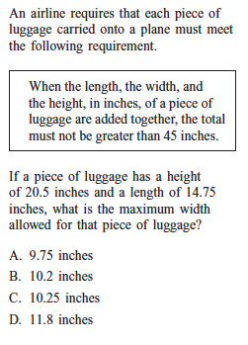

10) Icebergs are large chunks of ice that break off from glaciers and float in the ocean. Small icebergs are called growlers. But icebergs can also be huge. As little as one-eighth of an iceberg is visible above the water. Most of the iceberg lies below the surface of the water. Suppose an iceberg has a height of 6.5 feet above the water with the bottom tip of the iceberg at – 42.75 feet. What is the height of that iceberg from bottom tip to top?

