Introduction to tree diagrams
Name…………………………………………………. date………………

P( red) =

P(blue)=

Sam takes out one ball and records the colour and puts it back. He then takes another ball and again records its colour.
List the different combinations he can pick.
First pick | Second pick
You can list all the outcomes in a tree diagram.
Pick 1 Pick 2
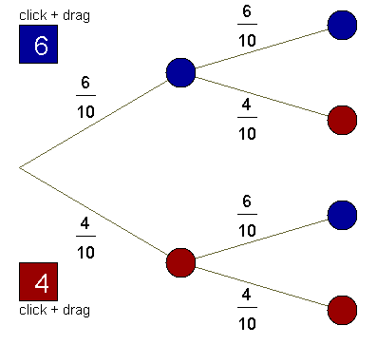
What is the probability I get 2 red counters?
P() =

P() =

