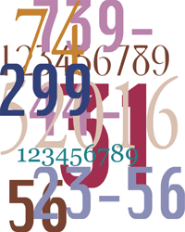

Integer Practice Problems

1) With the help of her science teacher she is doing an experiment on the affect of
low temperatures on bacteria. She cools one sample of bacteria to a temperature
of $-51°C$ and another to $-76°C$. What was the temperature difference in the
two experiments.

2) On Tuesday the mailman delivers 3 checks for $5 each and 2 bills for $2.75 each.
If you had a starting balance of $24, what is the ending balance in your account?

3) You owe $225 on your credit card. You make a $55 payment and then purchase
$87 worth of clothes at Macy’s. What is the integer that represents the balance?
owed on the credit card?

4) If it is $-$25$°$F in Rantoul and it is 75$°F$in Honolulu, what is the temperature
difference between the two cities?

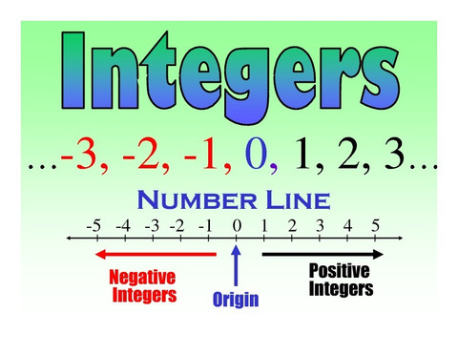

5) During the football game, Justin caught three passes. One was for a touchdown
and went 52 yards. The other was for a first down and was for 17 yards. The
other was on a screen pass that did not work so well and ended up a gain of $-$10
yards. What was the total yardage gained by Justin on the pass plays?

6) James plays in the backfield of the Medfield football team. Last week he ran four
plays from the halfback position. He made “gains” measured in yards of 3, 4, and
1 and 5. What were his average yards per gain? Round your answer to the
nearest tenth of a yard.

7) In golf, the average score a good player should be able to achieve is called “par.”
Par for a whole course is calculated by adding up the par scores for each hole.
Scores in golf are often expressed at some number either greater than or less than
par. Ms. Floop is having a pretty good day at the Dedham Country Club. Her score
so far after 15 holes is $-$3. If par for 15 holes is 63, what is her score?

8) Explain the picture below in words and with a math sentence.

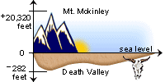

9) It was a very freaky weather day. The temperature started out at 9$°$C in the
morning and went to $-13°$C at noon. It stayed at that temperature for six hours
and then rose 7$°$C. How far below the freezing point (0$°$C) was the temperature
at 6 p.m.?

10) Jason received $22 from a rebate in the mail. He deposited this check in his
checking account that already had a balance of $43. Jason had expenses to pay
during the week. He wrote a check for $26.50 at the grocery store, and a check
for $12 for a movie ticket. His cable TV bill came due and he wrote a check for
$48. How much was in his account after paying these bills?

11) A monkey sits on a tree limb that is 25 feet above the ground. He swings up 10
feet , climbs up 6 feet more then jumps down 13 feet. How far off the ground is
the monkey now?

12) A submarine dove 836 feet. It rose at a rate of 22 feet per minute. What was
the depth of the submarine after 12 minutes?

13) On a college test, students receive 4 points for every question answered
correctly and loses 7 points for every question answered incorrectly. On this
particular test, Terry answered 87 questions correctly and 46 questions
incorrectly. What is his score on the test?

14) Use the following 4 integers: $-$1, 4, 40, −25 to create equations you with
an answer of 34. You can use each integer only once.

15) Solve the following equations:

a) ? $-$($-96)$ = 190

b) ? $-$($-2$) = $-12$ $- (-3)$

c) ( ? + $-2$) $∙$ ( ? $- -4$) = 27
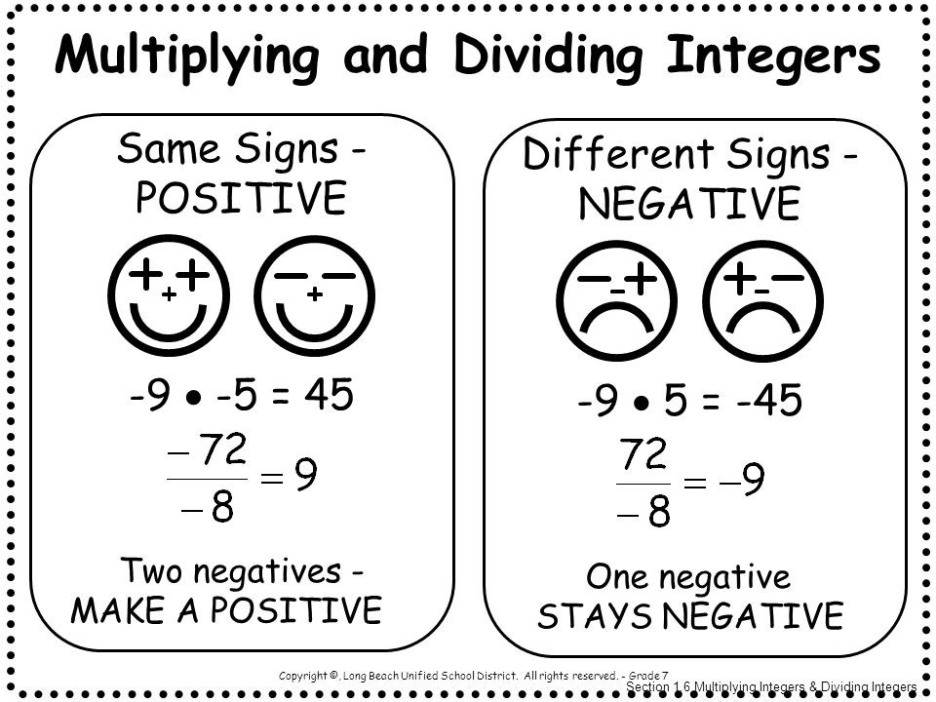

16) Give 5 integers whose product is less than zero and whose sum is $-26.$

17) Give 3 integers whose sum is $-12$. Use 2 negative integers and 1 positive
integer.

18) When you have a long string of positive and negative integers to add up,
what is a good strategy to make things more efficient? Explain in words and
give a number example to prove what you are saying.

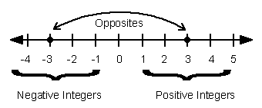

19) Why is taking away always like adding an opposite. Explain in words and give
a number example to prove what you are saying.

20) Is it true that if you add a negative integer to a positive integer, the sum is zero
or less? Is this true for all integers?

21) Is it true that if you subtract any 2 negative integers, the difference is always
zero? Explain your answer.

22) Is it true that if you add 2 opposite integers the sum is zero? Explain.

23) Is it true that if the mean (average) of a data set of integers is a negative integer,
then there must be more negative integers than positive integers in the data
set?

