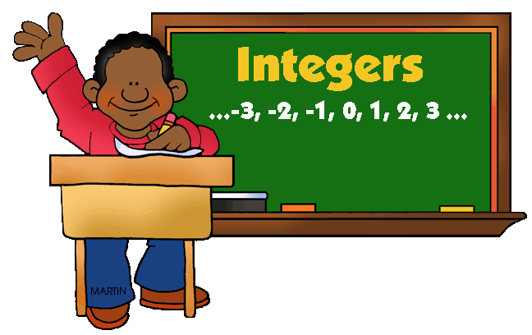
Integer
Practice

- Integers are whole numbers and their opposites and zero.
- Positive numbers are greater than (>) zero. (+4, +38, +479)
- Negative numbers are less than (<) zero. (-2, -44, -702)
- Absolute value is the distance a number is from zero.

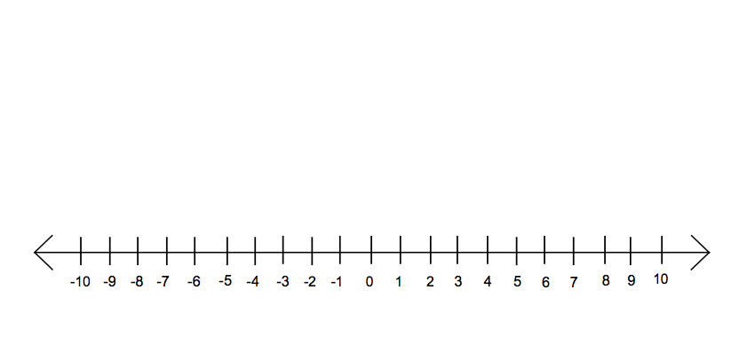

1) Place the following numbers on the number line: 3, -4, 0, 4, 1, -8, -2 .
Place the answers to a,b,c below on the number line. Circle the number that is
greater.

a) -1 or +2 b) -4 or -6 c) -10 or -9

2) Find each absolute value.

a) $\left|19\right|$ ____________ b) $\left|-2\right|$ ____________

c) $\left|-205\right|$ ____________ d) $\left|6-3\right|$ ____________

3) Fill in the blank with < > or =

a) $7 ____________$\left|-\$7\right|$ b) -3 ____________ 0 c) $\left|-6\right|$ ____________ 5

4) Name 2 situations where you would use a negative number to describe an event.

1) ___________________________________________________________________

2) __________________________________________________________________

5) Conrad recently opened a bank account. His account allows him to withdraw $5
more than his balance in the account (-$5). Conrad had the following
transactions in his account: (+20), (+6), (-4), (+2), (-25). Write a story to
describe Conrad’s transactions. What is his account balance after all 5
transactions? What does his final balance represent?

6. Carol and Tom invested in the stock market. Carol invested $225. After a month,
her stock went down to $185. Tom invested $380. After one month, his stock
went up to $440. Using absolute value, determine who had the greatest change in
their stock investments.

7. These ate the low temperatures one week in Duluth, MN. Order these integers
from least to greatest. 15$°$ , $-2°$, $-$7$°$, 9$°$, 4$°,$ 0$°,$ $-8°$.

8. At Sports Kingdom, bats regularly sell for $68. Today Carlos went to Sports
Kingdom because all baseball bats were on sale for $6 off. Last week baseball bats
were on sale for $65.

Write $6 off as an integer. ______________________

If the cost of a bat is written in integers, and Carlos buys the bat today, what would
the equation be?

a) (+68) + (+65) =

b) (+65) + ($-6)=$

c) (+68) + ($-6)=$

d) (68) + (6) =

Should Carlos have bought the bat last week? Why or why not? Explain.

9) Write 2 word problems using addition of positive and negative numbers. Share
them with someone near you (or in your group). Find the answers to the new
word problems you get.

10) Which integer would best describe each situation?

a) 35 degrees below 0 ____________ d) borrowing $17 ____________

b) a penalty of 15 yards ____________ e) diving 30 feet under ____________
water
c) receiving a $6 tip ____________

11) Use rules for adding integers with opposite signs:

a) (+2) + ($-3)$ = b) ($-\left(-6\right)+(+4)=$ c) (+7) + ($-11) =$

d) ($-$14) + (+7) $=$ e) (+22) + ($-$17) $=$

12) Use the commutative property to rewrite these problems. Group additive
inverses together and group integers with the same sign together. Then solve.
Note: The opposite nuber is called its additive inverse.

a) (+6) + (+2) + ($-$6) $=$

b) ($-$11) + ($-$7) + ($-$11) + (+7) $=$

c) ($-$8) + (+7) + (+1) + (+8) + ($-$9) + ($-$1) + (+6) $=$

d) ($-$4) + (+6) + (+9) + ($-$10) $=$

13) Add. Use the same rules of adding integers.

a) (+24) + ((+78) $=$ b) ($-$ 24) + (+78) $=$ c) (+78) + ($-$24) $=$

14) When Rebecca woke up at 6 a.m. to feed the chickens, the temperature was
$-2℉.$ At 11:30 a.m., the sun has warmed things up by 22$℉$. What was the
temperature at 11:30 a.m.? Write a number sentence and solve it.

15) John entered the elevator and went down 9 floors. He had intended to go up, so
he stayed on and went up 12 floors. Write a number sentence to show how
many floors John ascended from the start of his elevator ride.

16) Judy has only $82 in her bank account which is below the minimum balance she
needs to get free banking services. The bank adds a $10 charge to her account.
Write an equation showing w2hat happened to her account and what her
balance is now.

17) Evaluate the following:

a) $\frac{6}{-2} =$ b) $-8 ∙ \left(4\right)=$ c) 10 $–\left(-2\right)\left(+3\right)=$

d) $\frac{-16 }{-8}$ = e) $-5 ∙ -3 ∙ -4 ∙ -1=$

